GENESIS

./



**Details**

|  |  |  |  |  |  |
| --- | --- | --- | --- | --- | --- |
| **Ver. Rel.**  **No.** | **Release Date** | **Prepared. By** | **Reviewed By** | **To be Approved** | **Remarks/Revision Details** |
| 1.0 | 01-01-2021 | Madhushree C |  |  |  |
|  |  |  |  |  |  |
|  |  |  |  |  |  |
|  |  |  |  |  |  |
|  |  |  |  |  |  |

Contents

ACTIVITY 1: 4

SUMMARY: 4

ACTIVITY 2 and ACTIVITY 3: 4

SUMMARY: 4

ACTIVITY 4: 5

SUMMARY: 5

MINI PROJECT: 5

SUMMARY: 5

REQUIREMENTS: 5

GITHUB LINK: 5

# ACTIVITY 1:

## SUMMARY:

We built a source file in notepad++ and wrote a makefile code and complied it in command prompt. This activity was based on to compile any code without using any IDE.

## 

**Fig 1: Output in command prompt**

# ACTIVITY 2 and ACTIVITY 3:

## SUMMARY:

In Activity 2 we created a linker script for one section of memory using Gitbash Tool. Activity 3 was about to find the various address of the ISR and change their priorities.

# ACTIVITY 4:

## SUMMARY:

This activity was about to write a small script to design a makefile.

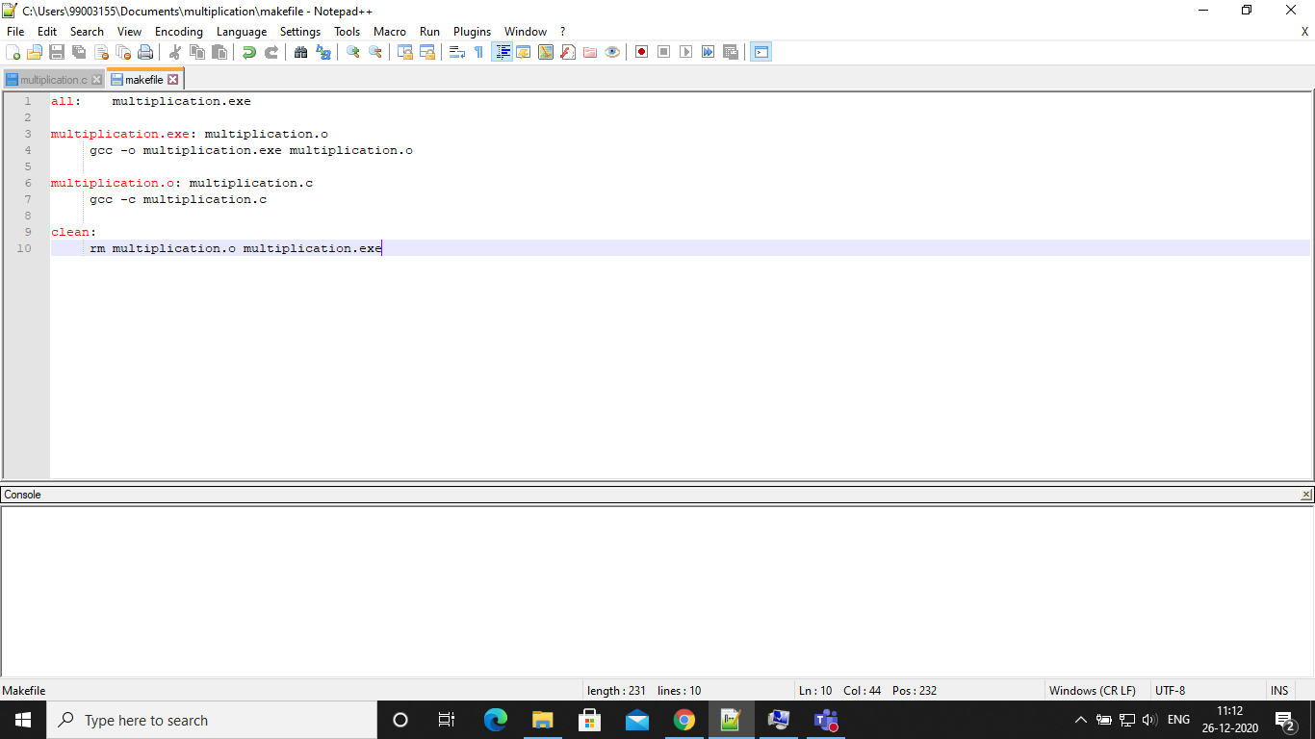

**Fig 2: Makefile**

# MINI PROJECT:

## SUMMARY:

We did a human detection project using PIR sensor, where whenever a human is detected the red led is turned on and otherwise the red led will be in off state.

## REQUIREMENTS:

* + STM32 Board
  + PIR Sensor
  + STM32 Cube IDE
  + Jumper wires

## GITHUB LINK:

https://github.com/99003154/PIR